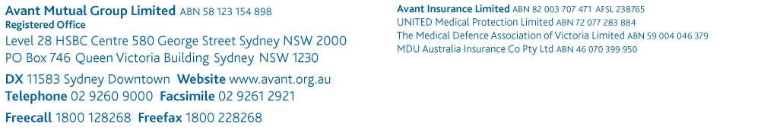
[PLEASE DELETE THIS COVER SECTION]

Disclaimer

The suggested template is intended for use as a guide of a general nature only and may not be relevant to particular practices, patients or circumstances. Persons implementing any recommendations contained in this publication must exercise their own independent skill or judgment or seek appropriate professional advice relevant to their own particular practice. Compliance with any recommendations will not in any way guarantee discharge of the duty of care owed to patients and others coming into contact with the health professional or practice. This publication is not comprehensive and does not constitute legal advice. You should seek legal or other professional advice before relying on any content, and practice proper clinical decision making with regard to the individual circumstances. Avant is not responsible to you or anyone else for any loss suffered in connection with the use of this information. Information is only current at the date initially published.

© Avant Mutual Group Limited 2014

Complaint register

Date and complaint no. | Received by (initials) | Received from  (name, address, phone no.) | On behalf of | Communication method | Issue | Action | Outcome | Active or closed
(NB: If complaint is still active, proceed to Complaint details form)
Signed: |  |  |  | Date: | / /

