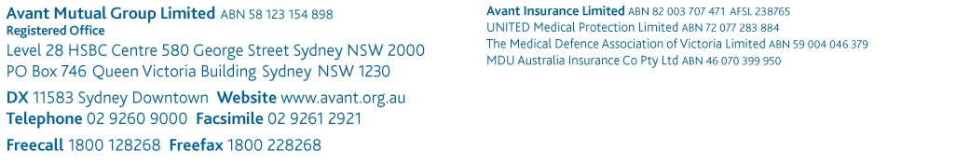
[PLEASE DELETE THIS COVER SECTION]

Disclaimer

The suggested template is intended for use as a guide of a general nature only and may not be relevant to particular practices, patients or circumstances. Persons implementing any recommendations contained in this publication must exercise their own independent skill or judgment or seek appropriate professional advice relevant to their own particular practice. Compliance with any recommendations will not in any way guarantee discharge of the duty of care owed to patients and others coming into contact with the health professional or practice. This publication is not comprehensive and does not constitute legal advice. You should seek legal or other professional advice before relying on any content, and practice proper clinical decision making with regard to the individual circumstances. Avant is not responsible to you or anyone else for any loss suffered in connection with the use of this information. Information is only current at the date initially published.

© Avant Mutual Group Limited 2014

Policy manual template

Proposed policy items
The following are proposed for inclusion in a policies and procedures manual, adapted to suit individual needs. It should be noted that accident reporting requirements vary from state to state. For the most up to date occupational health and safety requirements in your state, contact your local state department of industrial relations.

Accident reporting
All injuries and incidents are to be reported to the practice manager as soon as possible. This includes any accidents occurring during travel to and from work as well as during travel for business e.g. to bank, post office etc.

An incident form is to be completed and signed by the person sustaining the injury as well as any witnesses.

The practice manager is responsible for completing the appropriate forms to be submitted to the statutory workers’ compensation organisation.

It is usual for the workers’ compensation insurer to arrange a return to work plan in consultation with the practice manager and a rehabilitation provider. This organisation arranges follow-up care for the person sustaining the injury.

Ergonomics/workstation setup
Practice members are educated on correct body positioning while sitting at their workstation.

When sitting at the workstation, the staff member must be comfortable, regularly exercise and stretch to prevent repetitive strain.

Manual handling/lifting heavy objects
Manual handling is any action including lifting, pushing, pulling, holding or carrying. When considering moving an object:
- determine if there is a better way of lifting or moving the object
- if the object is safe for lifting ensure the:
  - knees are bent
  - back is straight
  - load is as close to the body as possible
leg muscles rather than the back are used for lifting.
- where possible, use a lifting aid and try to avoid unnecessary bending, reaching or twisting
- prevent slips and falls by wearing appropriate footwear, have adequate lighting, ensure there are no obstacles, and clean floors, with spills being wiped immediately
- weight limits: seated up to 4.5kg, standing 16-20 kg.

Fire safety
All staff must be aware of the location of fire exits, fire extinguishers, fire blankets, fire exits and fire emergency number (000) and local fire brigade number (xxxx).
All staff must be aware of their tasks in the following:
- notifying the fire brigade of the fire (information the fire brigade will need includes suburb, street number, location, access, fire and building status, chemicals)
- providing patients direction to the exits and assembly area
- obtaining and checking list of employees and patients in the building at the time of the fire and undertaking a check against the list at the assembly area
- collecting necessary documentation or equipment and fireproofing cabinets or rooms.

Armed hold-up
In the event of a robbery during practice operating hours, protect patients and staff members from injury. Cooperate with the requests of the assailant to avoid conflict, realising that harm to people is worse than losing the day’s takings or drugs.

At the earliest possible opportunity, contact the police to report the incident and the ambulance if anyone has been injured, and also the insurance company.

The practice should be isolated (closed). Avoid touching any surface or items, particularly those that the assailant may have come in contact with as the practice will be treated as a crime scene and police will need it to be unaltered.

If you witnessed the crime do not speak about it until the police arrive – this often corrupts your thoughts. Take yourself away from the scene, recall to yourself what happened or any distinguishing features and write these down.

Give thought to the height of the assailant by measuring him/her against things in the office, e.g. the door handle.

Money
As little money as possible should be kept on the premises at any one time. Ideas to assist in managing this security risk:
- Display a sign advising minimum or no money kept on site overnight and during the day.
- Encourage electronic banking.
- Bank twice daily.
- Vary the route, employee and bag used for taking money to bank.
- Use a safe.

Drugs of addiction
Drugs of addiction must be kept and maintained in accordance with the relevant state pharmaceutical management legislation. Contact your state department of health for further information.

